Higher Education in China: With Sichuan University as a Case
(II)

Xin WANG Jian SHI

As we have discussed in our previous paper, Chinese higher education in its development has been closely tied up with China’s political, economic, social and cultural development, and it has played an important role in the changes of China in every aspect. When we moved into the 21st century, China has kept its speedy development in economics and social changes, and with the continuing reform and development the higher education in China has undergone still greater changes.
With the quick development of China’s higher education and the enlargement of the universities and colleges, the number of the universities and colleges has increased quickly, and the students at the campus and graduated from the higher education have also increased at an unexpected speed. As we have mentioned in the previous discussion, around 2005 the Ministry of Education in China had a big move in administration of the higher education nationwide from the quantity to quality in student enrollment and education itself. A nationwide educational quality control inspection was carried out, which for the first time in over 20 years set up regulations and quality-control measures in undergraduate programs. The attention of the education policy makers and university administrators has also shifted from the physical enlargement of the school, the campus construction and the improvement of the hardware of the campus, to the quality and software building-up and from the research and graduate studies to undergraduate programs and undergraduate education.
In the 10 years, particularly in the recent 5years, of 2005-2015 the education and higher education in China are going through some more comprehensive changes. In April 1986 China had issued its Compulsory Education Act for the basic education of the kids from 6 to 14, and the revised compulsory education act in June 2006 makes the nine-year compulsory education available and this act started to be fully implemented in Fall 2008 with its characteristics of being compulsory, free in tuition fee and cost, and propagate. Another major document issued in this period is The National Education Reform and Development of Long-term Planning Programs (2010-2020), which was opened to the public in February 2010. All these government policies and strategic plans and their implementation have provided the education a much better environment for further development. If we say that the speedy development of higher education in China since the reform started in late 1970s was mainly in the capacity and physical size of the campus and facilities, which improved the hardware conditions for higher education, and then in these recent 10 years the speedy development of higher education is shifting from the extensive to intensive development.
In the intensive development the new perspective for higher education focuses on the quality of education, and it emphasizes that cultivation of the students should meet the needs of the economic and social development, meet the needs and expectation of the changing society and meet the needs and individual design of the students themselves of the ‘90s generation. In the further deepening development of higher education in China the keywords are comprehensive education and cultivation, quality and equity, knowledge and ability, teaching standards and regulations, methodology and innovation, international perspective and local service, and teachers’ training and ability. These major points are to have a new perspective of diversified training of students to meet their diversified individual needs and to meet the needs of the job markets, and further to meet the needs of the China’s quick development.
If we go into the detailed significance of the above keywords and major points in higher education, we could easily notice that the further development of the higher education is shifting to a more healthy and objective way. In the over 20 years since the reform, the universities and colleges all set up very high and ideal goals for their development, which are usually not realistic to their own condition and background, all would like to be comprehensive, international, high level ones. The students had no choices once they came into the university, and they could not have their satisfied cultivation and education for their interest and their ability through the courses and campus education. The curriculums are normally designed to meet the requirement of their academic majors, not to meet the needs of the students, and the credit system at the campus is still a rigid planned system, which have not given the students the flexibility for their individual talent and development. The students from the top-level universities to the local colleges would be trained in the same mode and taught in the same way. The universities and colleges would rush to open up new undergraduate majors according to the popularity of the job-markets, and the students normally compete for jobs with various certificates and diplomas, not with their abilities, at the job-markets. Some college graduates would soon find out that the most popular majors at their college entrance time would be the majors that would be most difficult for their graduates to find jobs upon their graduation in 4 years. With the problems challenging the university, what would they do?

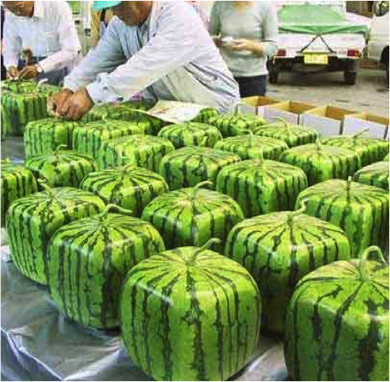

The practices at Sichuan University would give us something to think over, and it also represents some major reforming actions of the universities in general in China.
In the new reform and perspective for higher education in China, the high-level faculty and staff are the priority and guarantee, the teachers’ quality and perspective are crucial for the comprehensive and quality education. The faculty building from the academic research oriented to both academic research and teaching orientated in Sichuan University takes the first step in its further reform. All the professors of Sichuan University are required to teach undergraduate courses, and all their research labs and programs are encouraged to open to the undergraduate students. The evaluation and academic promotion system for the faculty is adjusted to be more teaching-focused. In Year 2014 Sichuan university started its first distinguishing teaching award, in which the awards are one-million yuan RMB for the best prize, and five-hundred-thousand for the first prize, three-hundred-thousand for the second prize and one-hundred-thousand for the third prize, with the three million funding donated for the teachers’ awards by the alumni each year. 12 teachers selected by their students and fellow colleagues won the above awards last year. The university has 21 different awards for the best teaching, best textbook, best young teachers and more. The evaluation and assessment of the teachers’ teaching and research work becomes more diversified and individualized. While the university provides best conditions to attract the outstanding talents from abroad of both Chinese and international citizens for its new faculty, Sichuan University also sends its talented young faculty abroad for a one-to-three-years training. The teaching positions are only available to those who have both doctoral degree and the teacher’s certificate from the faculty development training center which is co-constructed by University of Michigan and Sichuan University.
For a better teaching and learning environment, Sichuan University from 2013 has refurnished its classrooms and teaching facilities. All the fixed chairs and desks were replaced by the moveable furniture, and digital equipment provided in all classrooms and students’ areas to encourage inter-active discussion, and seminars replace the lecturing in teaching as well. Heuristic and small class teaching replace the inculcating methods. The teacher-centered teaching is replaced by the student-centered classroom discussion, while the teachers change into the promoters’ position. The class size is reduced from big classes of over 60 to 150 students to much smaller classes of about 30 students each. The problem-based discussion replaces the traditional lecturing in the teaching methods to encourage the students to have their own voices and ideas heard in class. Much more attending now in the learning gives to the three abilities of the students: the ability to learn, the ability to create and criticize, and the ability to articulate both in speaking and writing. With the discussion and individual students’ hands-on practice, their knowledge acquiring is achieved through their experience in practice, and eventually they gain their wisdom through the experiences they going through at the campus.
“Public entrepreneurship and public innovation” are the catchwords，popular now, in the economic and social development in China. Since 2013 the central government and the Ministry of Education have more effort and give more attention to help the revitalization of the vocational education, which had been ignored and open only to the students of lower scores at national college entrance exam, and this move also help all the universities and colleges in China to review their students education and cultivation in innovation and entrepreneurship. At the campus of Sichuan University entrepreneurship and innovation also become popular. Sichuan University encourages students to set up their associations and societies to team-up the students with common interest or talent, faculties provide their tutoring and guide for the students’ innovative practice, and the university provides seed money to help them to put their ideas in practice. The graduates now could apply for some seed money to start their own business or enterprises upon their graduation. The undergraduate programs in various disciplines have now designed more projects for the training of the students’ innovative thinking and ability, academic professionals from both within and without the campus are invited to be their tutors in the projects and offer the students some intensive lectures based on their career experiences, and these off-campus tutors and instructors are normally from the alumni of the university.
To satisfy the needs of the students and offer them more opportunities to develop independently, Sichuan University has implemented its 323+X model in undergraduate programs， which is a comprehensive undergraduate education project replacing the traditional ways. The modern technology and IT make the elite education available and possible to all the students at the campus. For the 323+X model: 3 is for elite education, individualized tutoring and comprehensive education; and 2 is for the two stages of the curriculum design, 1.5 years and 2.5 years (a 4-year-undergraduate program), in which 1.5years for comprehensive cultivation and 2.5 years for discipline-orientated training and education; the second 3 for three types of talented students, science and academic research orientated, creative and innovative orientated, and practical and applied skill orientated; and the X for 10,000 courses available to the students covering humanities, social science, natural science, engineer and medical science. This model is intended to provide diversified courses and lab work to satisfy the students’ individualized plans, to develop the students’ special talents, to extend the students’ publicity personality, and to excavate the students’ quality. This helps the students to adjust their orientation, learning methods and helps them have an inter-discipline or cross-discipline perspective during their 4 years with the university.
For a university located in West China, Sichuan University has its effort to bring the world to its local and take the local into the global. Internationalization is its strategy to upgrade its quality both in education and research. In the 5 years since Year 2000, it had built up exchange programs and collaboration relations with over 150 universities and colleges in 42 countries and regions. In the 5 years it had invited 2200 international teachers and experts to lecture at the campus for both short time and lengthened time, it hosted 6815 person-time international visitors for academic conferences and collaborations, and at the same time it sent 3644 person-time faculty and staff to study and visit abroad. The above numbers have been doubled and tripled in recent 10 years. Since 2012, Sichuan University has its UIP (University Immersion Program) every summer, localizing the global education and offering every student at its campus the international studies experience by bringing the international scholars, teachers and students onto its campus.

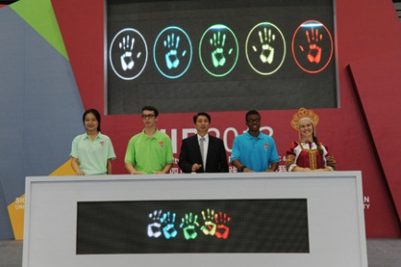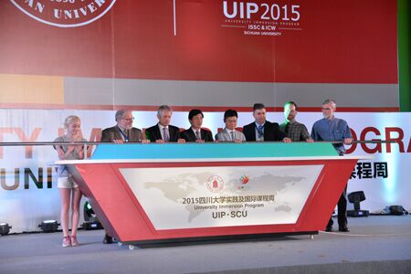

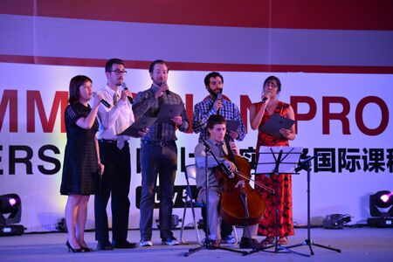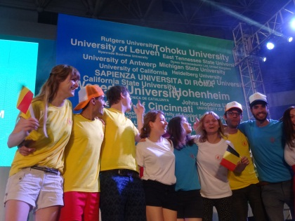

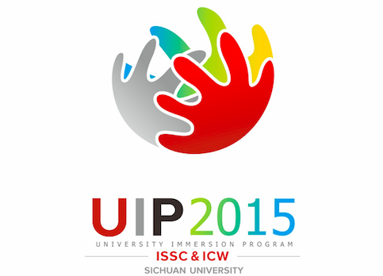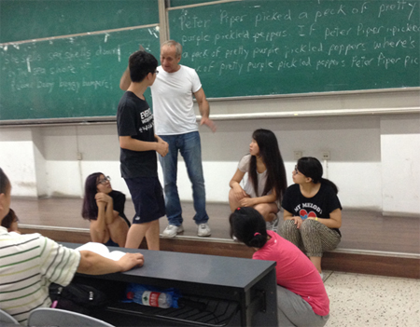

At UIP 2015 of Sichuan University, 169 international scholars and teachers and over 400 international students coming from 96 universities including Harvard, Cambridge, Oxford, MIT of 24 countries joined the UIP. Dr. Xie Heping, the president of Sichuan University, pointed out, “Creating international atmosphere and environment for the campus and cultivating high-level students is the responsibility of the university. UIP is the important strategy of Sichuan University in enhancing its internationalization both in education and education quality.” President Simon Gaskell of Queen Mary, University of London, on behalf of all the international scholars and teachers of UIP, said at the opening ceremony of UIP 2015, “Coming from different universities and countries, we gather at UIP of Sichuan University. In the practice of idea exchange and research in cultural differences, we may find eventually that we have more similarities than the differences.” In UIP 2015, 188 courses offered in English by international scholars and teachers covering humanities, social sciences, natural sciences, engineering and medical sciences, about 30-thousand undergraduate students had the opportunity to select from the courses offered at the UIP, and the 400 international students, together with the Sichuan University students, selected their courses offered both by the international and Chinese scholars and teachers. Sichuan University successfully achieves its goal of localization of internationalization and makes its students have the international experience at its own campus.
In the age of Big-data and internet +, the students’ learning habit changes. On the one hand, they are very skillful at searching for resources and we-chatting each other, and on the other hand, they are so eager for concern and communication at

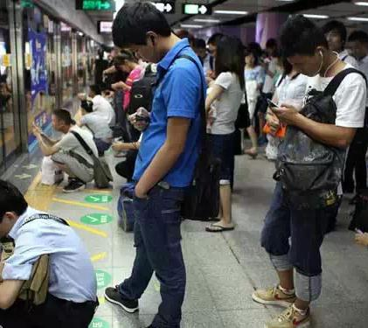
the campus and class environment. How to explore the IT and modern technologies for more efficient teaching and learning becomes a question for both the administrators and faculties at the campus. The Teachers Development Center at Sichuan University organizes international and domestic conferences, offers

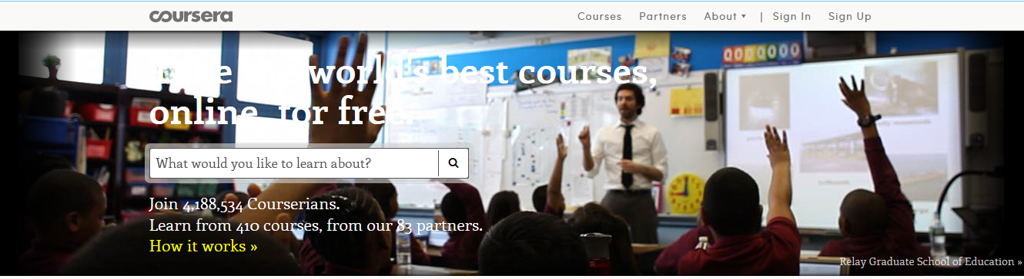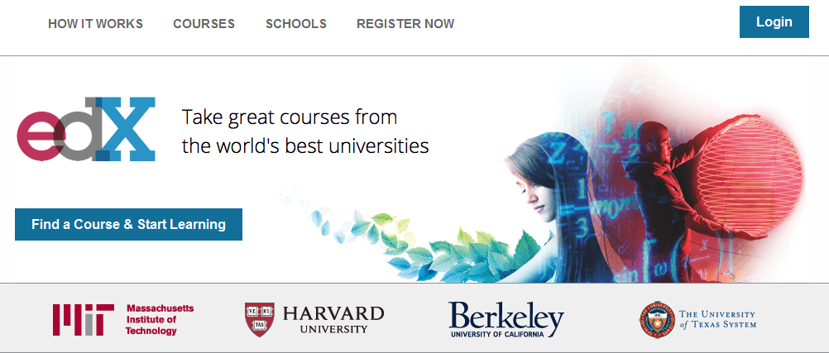

training programs for the teachers, helping them get acquainted with the new teaching methodologies and with the modern facilities. Mooc, short video-lectures, flipped classroom, all these pedagogical models, in which the typical lecture and homework elements of a course are reversed, are discussed and practiced by the faculties. The shifting from teacher-centered to student-centered class facility set-up, the reduce of the lecturing time and lengthening of the class learning through the modern IT facilities are changing the perspectives and ways of learning and teaching at the campus. More resources are available for the students for their independent studies. The keywords in class conducting are also changed with the new perspectives: enquiry, exploration, searching and discovery which are encouraged for the students to train their innovative and creative abilities. And for the teachers’ side, enabling, enlightening and engaging are getting more attention in their course work and teaching.
The discussion above about the speedy changes in China’s higher education, which are accurately reflected in Sichuan University’s move forward, gives us a clear picture of the development of education, particularly higher education, in China. At the same time we have a still greater expectation to anticipate what the further reform in National College Entrance Examination, in college and university enrollment in 2017, the reshaping and revitalization of the vocational colleges nationwide and the work on national guideline in education and academic quality-control for every university and college discipline would bring to the higher education in China for a still further and deeper reform. We are confident that by Year 2020 China’s higher education will for sure have its strength and new phase with the quick development in following five years.

Reference:

- 《国家中长期教育改革和发展规划纲要（2010-2020）》[Z]. 北京：人民出版社，2010. (The Outline of China’s National Plan for Medium and Long-term Education Reform and Development (2010-2020).
- 教育部， 2014, “2014教育统计数据”[OL]. (Education Statistic Data of 2014, MOE).
- 刘延东.“在世界语言大会开幕式上的致辞”[R]. 2014年6月5日，苏州. (“The Opening Remark at the World Language Conference by Vice Premier Liu Yandong”).
- 《中共中央关于进一步深化改革的重大决定》[Z]. (CCP’s document of important decisions for further deepening reform).
- “基本实现教育现代化进入全面攻坚阶段：2015年全国教育工作会议召开”， “教育新常态下的改革新思维—2015年全国教育工作会议观察，”“破冰，破解，破土—2014年教育工作亮点，”“起点，节点，支点—2015年教育工作要点”[N]. 中国教育报，2015年1月24日. (“Basic Realization of Education Modernization and Entering a Comprehensive Critical Stage: At the Opening of 2015 National Education Conference,” “The New Thinking in Reform under the New Education Normal: Observation at the 2015 National Education Conference,” “Ice-breaking, Significance-cracking and Ground-breaking: The Bright Spots of Education Work in 2014,” “Starting-point, Node-point and Pivot-point: The Key-points of Educational Work in 2015”).
- 四川大学校网 http://www.scu.edu.cn/
- 四川大学档案馆 http://archives.scu.edu.cn/

Jian Shi, Professor of English at English Department of Sichuan University, Ph.D. from Lehigh University, U.S.A. and Xin Wang, Professor of English, Chairperson of English Department at Sichuan University, Ph.D. from Sichuan University, China.

